CS 157A Intro to Database Management Systems

Project Data Model & DB Design Document

Project Title: Stock Data Aggregation Web-App

TEAM 34

Sachin Shah

Yang Li

En-Ping Shih

Professor: Dr. Mike Wu

TA: Sriram Priyatham Siram

San Jose State University

October 8th, 2019

**ER-Model**

For our Entity-Relationship Model diagram, we used red to represent entities, blue for attributes and green for relationships. As it shown on Figure 1 below.

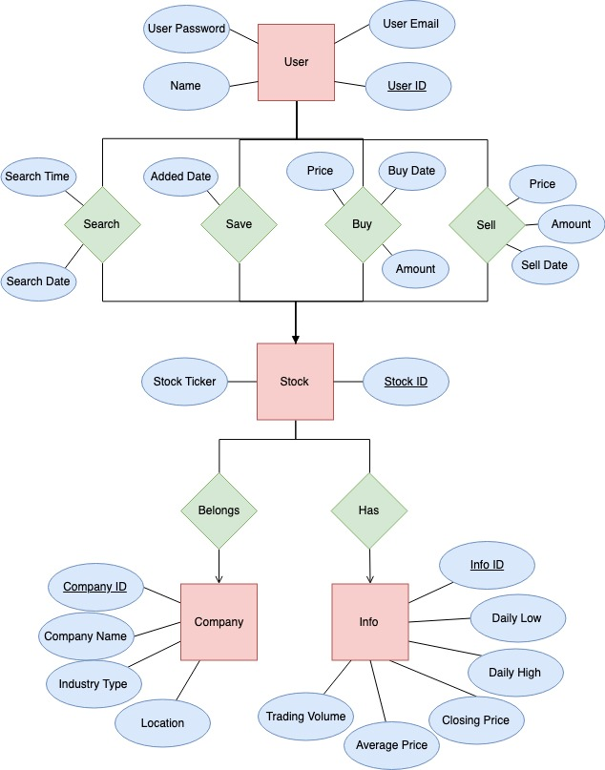

Figure 1. ER-Model

**Table**

Table 1) User (UserID, Name, User Email, User Password)

There are many users of our application, and this table is an example of how that information would be stored.

Table 2) User Search (StockID, Search Time, Search Date)

From each user’s search history list, each stock will have a timestamp of when the user have searched for the search via the search bar.

Table 3) User Save (StockID, Added Date)

From each user’s saved list, each stock has a Stock ID and a timestamp of when it was saved to the user’s favorite list.

Table 4) User Buy (StockID, Price, Buy Date, Amount)

For Buy relationship, each stock has a Stock ID and a timestamp of when it was bought, the Stock price, the date and the amount the user bought.

Table 5) User Sell (StockID, Price, Sell Date, Amount)

For Sell relationship, each stock has a Stock ID and a timestamp of when it was sold, the Stock price, the date and the amount the user sold.

Table 6) Stock (StockID, Stock Ticker)

Each Stock has a table called information associated with it, Stock ID is again the primary key of the relationship.

Table 7) Stock Belongs(Company)

For Belongs relationship, each Stock belongs to a company.

Table 8) Stock has (Info)

For has relationship, each Stock has certain information.

Table 9) Company(CompanyID, Company Name, Industry Type, Location)

Each Company has Company Name, Industry Type, and Location.

Table 10) Info(InfoID, Daily Low, Daily High, Closing Price, Average Price, Trading Volume)

Each Info has Daily Low, Daily High, Closing Price, Average Price, Trading Volume)

